**BIO DATA**

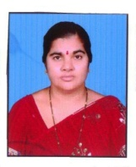

Name : Komera Venkata Ramana

Father’s Name : Yellamanda

Mobile : 8331808609

Email id : kvramanaa@gmail.com

Gender : Female

Date of Birth : 10.04.1974

Marital Status : Married

Religion : Hindu

Nationality : Indian

Languages Known : English, Telugu & Hindi

Education : M.Sc.(Botany), M.Phil., APSET-2017.

Experience : 17 Years

Address : D.no.12-2-108, 10th Ward,

Macherla, Guntur -522426. AP.

Declaration

I hereby declare that all the information provided here is true to the best of my knowledge.

Place:

Date: (KV RAMANA)